Our build in Elida will be house #55 for the Lima Area Habitat for Humanity, but the first in the city of Elida. We will be able to provide a build schedule for the house in the near future. (Please check back soon for those details and sign up: https://www.habitatlima.org/volunteer/volunteer-interest-form.html ) Build days will occur on most Saturdays this summer. We will not only need construction workers, but also people to help feed our volunteers. And we need people to donate money in order to help sponsor the build. Pay for one square foot of the house for only $62 or pay for 100 square feet or more. Donate now: https://www.habitatlima.org/donate/donate-now.html Thank you for being a part of this wonderful process—providing decent, affordable housing for this family through the generosity of good people in the area.

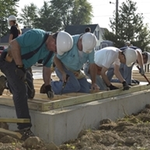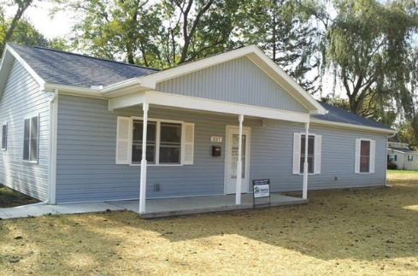
VOLUNTEERS + DONATIONS = NO PLACE LIKE HOME

